**Question 1**

Explain why a public good will typically be under-provided by the private market.

**Answer:** A public good is a good that is both non-rival – consumption by one person does not prevent others from consuming it – and non-excludable – it is not possible to keep anyone from consuming the good. Because it is non-rival, if someone provides the good, it has benefits for others (like a good with a positive externality). Because it is non-excludable, there is now way to force others to pay for the enjoyment the receive from the good. As a result, there is an incentive for individuals to “free-ride” on the provision of the good by others, rather than pay for the good to be provided, even though they would benefit from more of the good being provided.

**Question 2**

A family of four – Dawn, Michael, Stephanie, and Ian – are thinking of installing a swimming pool in their home. Suppose that each will get greater enjoyment from a longer pool. Their individual demand curves for pool length are

Dawn: P = 6,000 – 200Q

Michael: P = 3,000 – 100Q

Stephanie: P = 1,800 – 60Q

Ian: P = 1,200 – 40Q

Q represents the length of the pool in meters. Suppose that the marginal cost of building a pool one meter longer is $2,000. (You may assume that each family member’s enjoyment of the pool is not affected by whether the other family members are using it at the same time.)

A. Draw the aggregate demand curve for pool length for the family.

B. What is the optimal pool length for the family?

C. Suppose that each family member had to individually and independently decide how many meters of the pool to pay for. How long would the pool that they would choose be?

**Answer:**

A.

Because it is non-rival and non-excludable within the family, the pool is a public good, so we much sum the individual demand curve vertically to find the aggregate demand curve. The easiest way to do this is by looking at the graph.

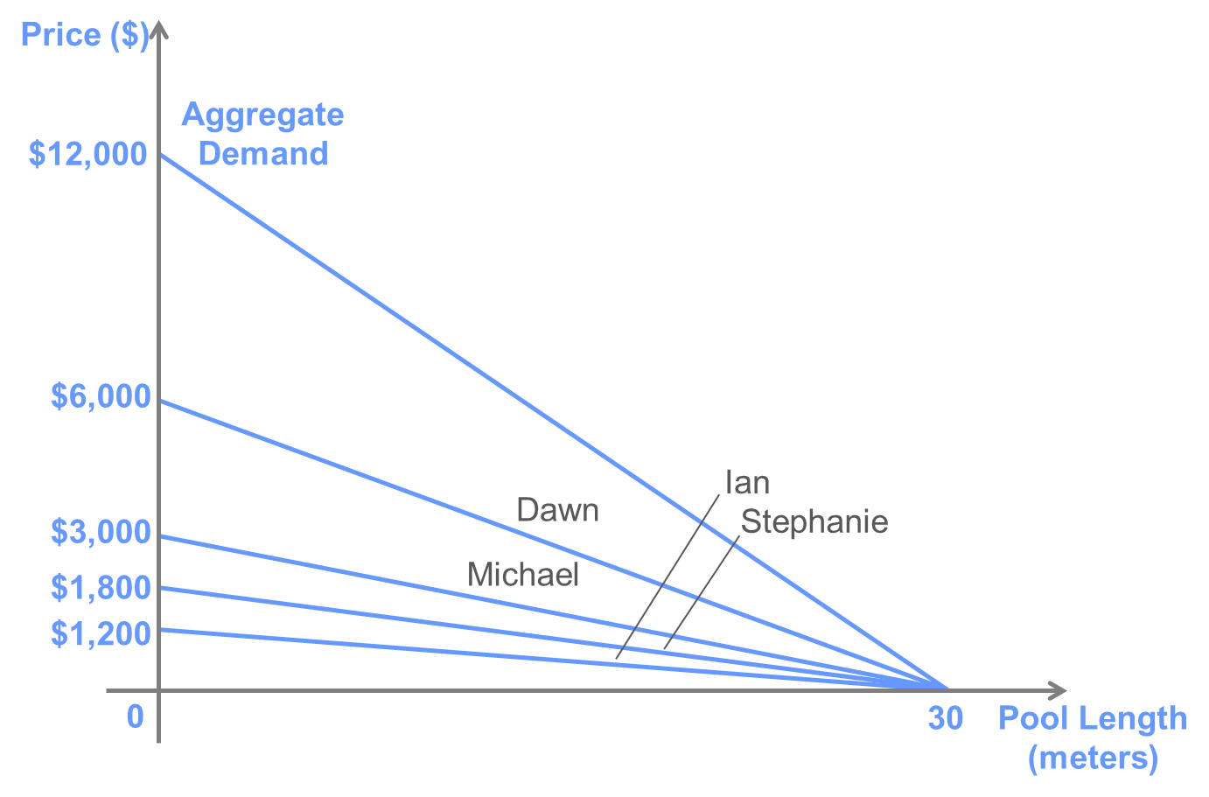

Alternatively, we could add up the equations for individual demand (as long as P is isolated on the left-hand side of the equations, so that they measure the marginal benefit, or willingness to pay, for each individual of the Qth unit of consumption). You can check that both methods give the following equation for aggregate demand:

P = 12,000 – 400Q

B.

The optimal pool length is the one for which the marginal benefit to the whole family is equal to the marginal cost. So, the optimal pool length is 25 meters (found by solving 12,000 – 400Q = 2,000).

C.

If the family members are unable to coordinate and buy the pool length that is best for the family as a whole, then their individual decisions are susceptible to the free rider problem. To see how long the pool will be, let’s start with Dawn’s decision. She will be willing to pay for a pool that is 20 meters long. Given that Dawn is already providing a pool that is 20 meters long, none of the other family members will be willing to pay for a longer pool. For example, Michael’s willingness to pay at this point is equal to $1,000/meter, which is below the marginal cost. So, everyone else will free ride on Dawn’s provision of the pool.

**Question 3**

Fred and Ted have the following demand curves for hectares of urban parkland:

Fred: P = 10 – Q

Ted: P = 1 – 0.1Q

A. Assuming parkland is a public good, find the aggregate demand curve for urban parkland.

B. Suppose that the marginal cost of maintaining urban parkland is $5/hectare. Calculate the quantity demanded individually by Fred and Ted.

C. Now, calculate the socially optimal quantity of urban parkland. Explain why this amount is different from the individually demanded quantities.

**Answer:**

A.

The figure below depicts the demand curves for Fred and Ted and the aggregate demand curve obtained by summing the individual demand curves vertically. Based on the graph, we can calculate that the aggregate demand curve is given by P = 11 – 1.1Q.

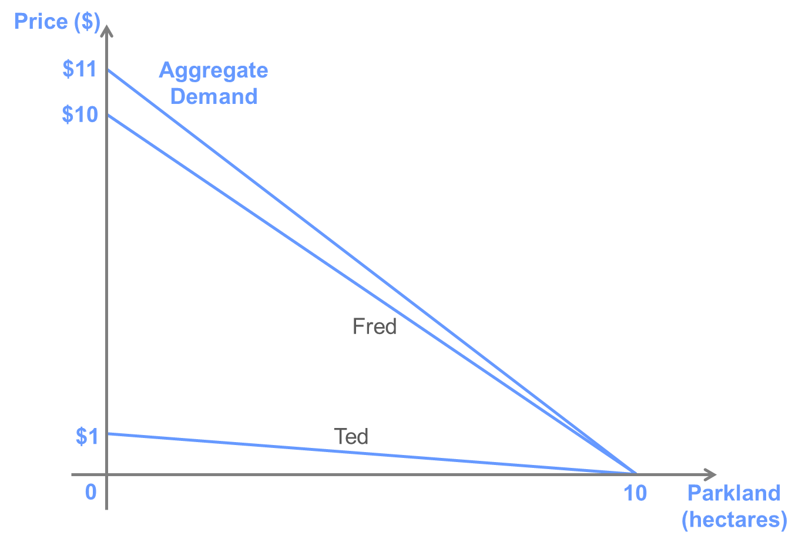

B.

Fred: Q = 5 hectares

Ted: Q = 0 hectares

C.

The socially optimal quantity is the amount for which the social reservation price is equal to the marginal cost, so Q = 5.45 hectares. (This is obtained by setting 11 – 1.1Q = $5.)

The socially optimal amount is greater than that demanded by either individual because the individuals do not take into account that providing the public good has benefits to others. If left alone, Fred would provide 5 hectares of parkland, and Ted would provide zero, free-riding off Fred’s provision of the good.

**Question 4**

Suppose that David and Danny are neighbors in adjoined houses that share a lawn. Both want to hire a gardener to tend to their lawn, and they have identical demand functions for the numbers of hours of gardening services to hire per week, which is given by P = 24 – 2Q.

A. If a gardener costs $20 per hour, what is the efficient number of hours for which to hire the gardener? B. Suppose that David and Danny cannot come to an agreement to share the cost of the gardener. What will be the deadweight loss associated with competitive market outcome?

**Answer:**

A.

Because the lawn in shared, the gardening services are a public good. Thus, we must add the individual demand curves vertically to find the aggregate demand for gardening services, as in the following graph.

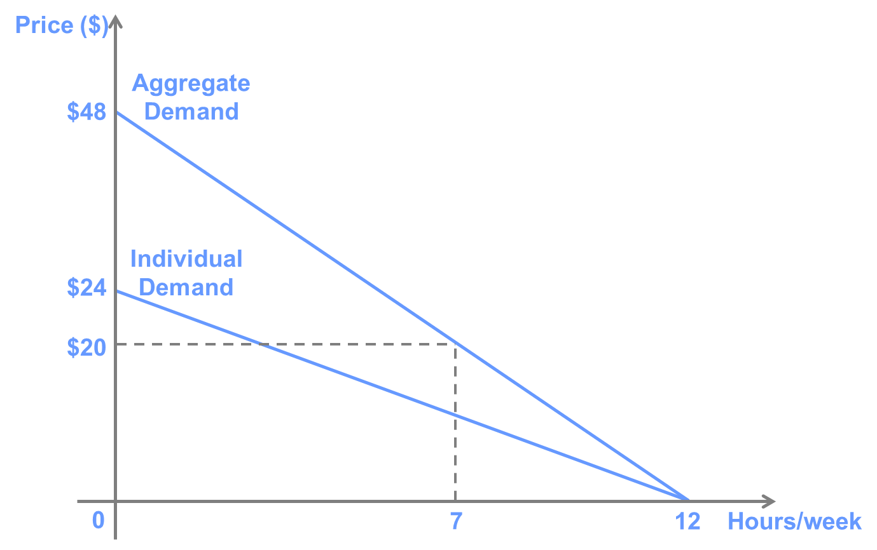

We can calculate that the equation of the demand curve is P = $48 – 4 Q. As a result, the efficient number of hours is 7 per week.

B.

If no one else were paying for the gardener, David and Danny would each be willing to hire the gardener for 2 hours. However, once one has hired the gardener, the other will not be willing to pay for any additional hours and will instead prefer to free ride and enjoy the gardening already paid for by the first neighbor. Using the graph, we can calculate the deadweight loss associated with this outcome is equal to ($40-20)x(7-2)/2 = $50.

